Free and Open VR for the Web

Since I wrote my first article on the topic six months ago, VRSpace.org open source VR server grew to a fully featured platform.
Main, user-facing features are
- web: all you need to access it is a web browser, so it's also
- cross-platform: it works on anything with a web browser, be it PC, smartphone, or VR gear.
- multi-user: people in the same space see each other's avatars
- VR motion tracking/inverse kinematics: your avatar mimics your movement, so you can wave your friends
- spatial audio streaming: voice chat with people around you
- text chat: if you prefer text for any reason
- video avatars: stream your webcam into 3D space
- screen sharing: essential for collaboration
On a glance, I've listed nearly all features that any VR community and collaboration tools out there have, right?
And it gets even better, as VR, PC and mobile users share the same 3D space.
And it's all free, open source.
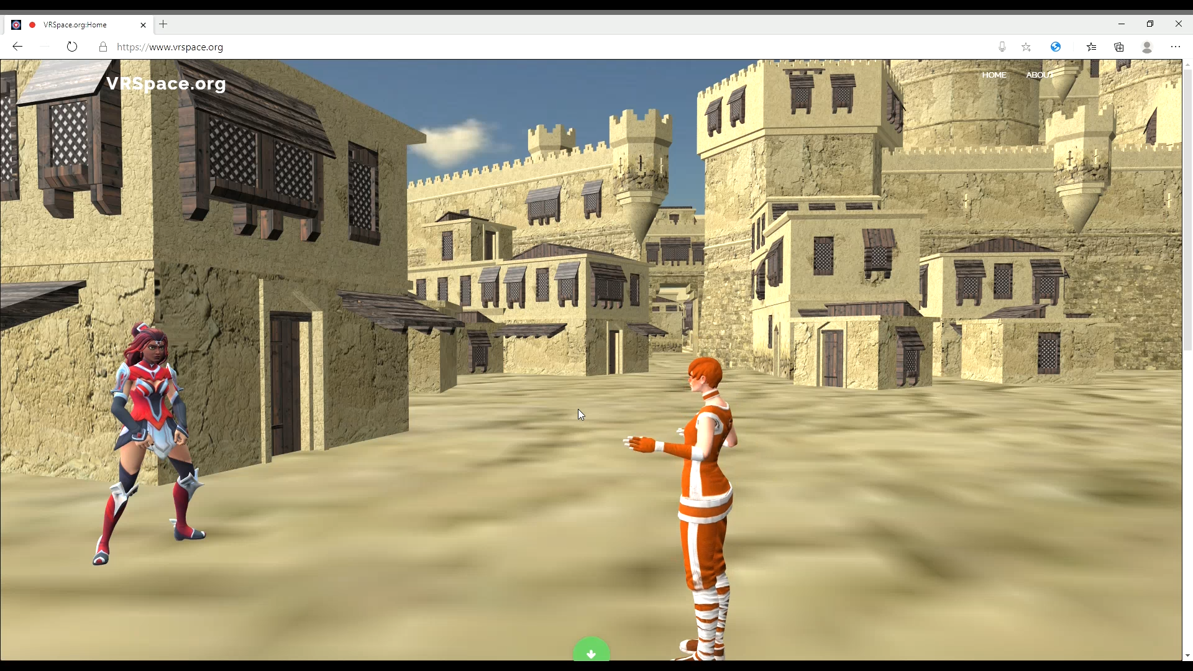A mobile user (left) meets a VR user (right), as seen by a PC user
Credits: shado222, JohnBoySchulz, farhad.Guli
There's a fully featured demo of latest software version along with 1GB of free 3D content running on VRSpace.org all the time, and you can try it yourself any time.

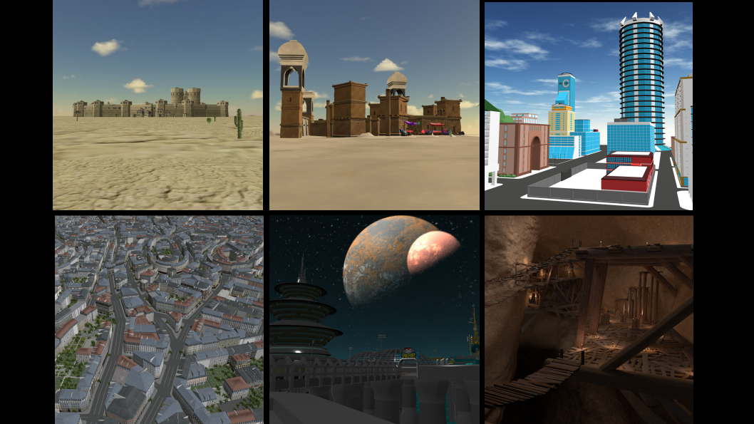Multi-user spaces available at VRSpace.org
Credits: farhad.Guli, anthwolf, fenixman12, ShadowTan, Binkley-Spacetrucker, exima113
Just go to VRSpace.org, choose your avatar first, either a 3D avatar or video avatar. While there, you can preview animations and/or poses your avatar can do, if any. You may also enter your nickname in the text box.
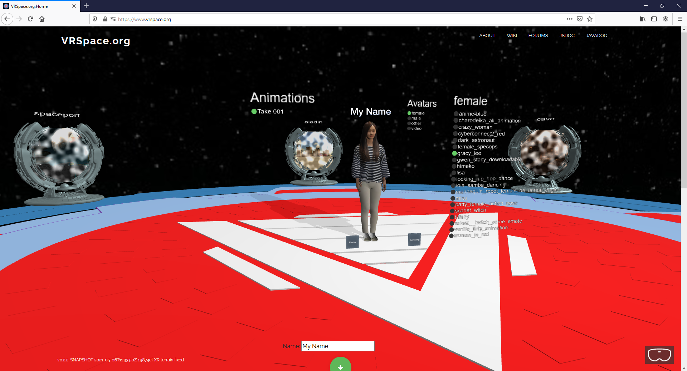Choose your avatar and enter a portal, optionally type your name and preview poses/animations
Once chosen an avatar, click on a portal to enter a multi-user world.
On PC, move using WASD or cursor keys, rotate dragging the mouse. On mobile, move and rotate dragging on the touchscreen. Gamepad is supported on both PC and mobile. If your device and browser support WebXR or WebVR, you’ll see VR goggles icon in bottom right corner, click on it and you’re in VR, then teleport around using VR controllers. In VR, the avatar will follow movement of your head and arms. It can also crouch, or jump.
While entering world, web browser will prompt for permission to use your microphone. If you allow it, everyone around will hear you. If you have chosen video avatar, the browser will also ask for permission to use your webcam.
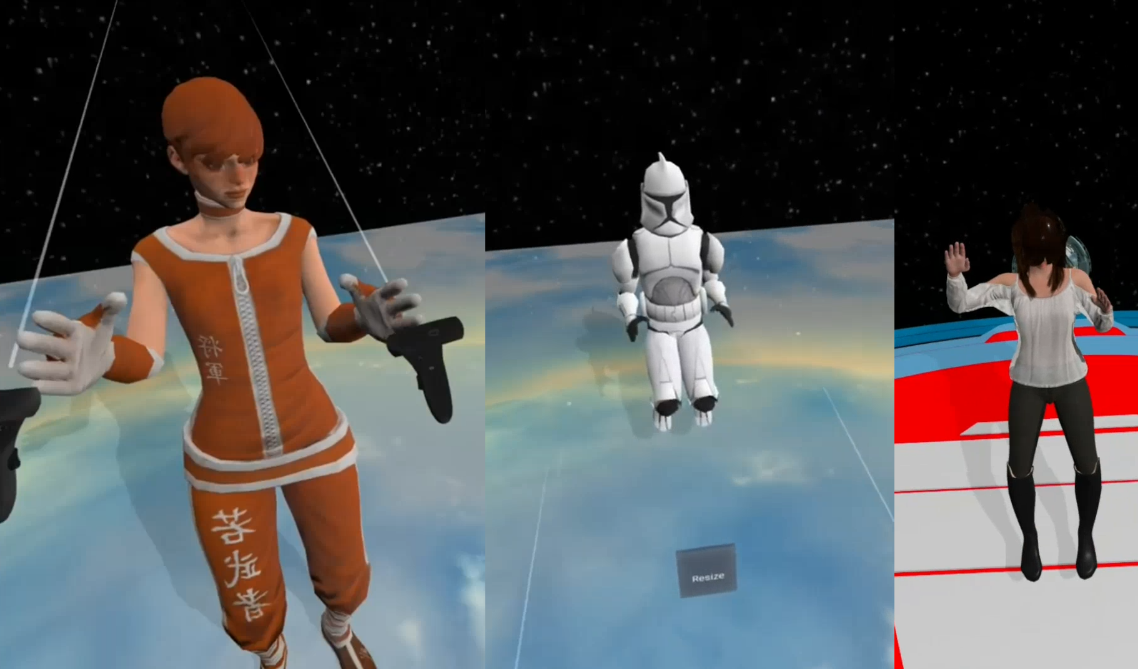Motion tracking and inverse kinematics in VR
Credits: JohnBoySchulz, Tributon, DiggenDigga
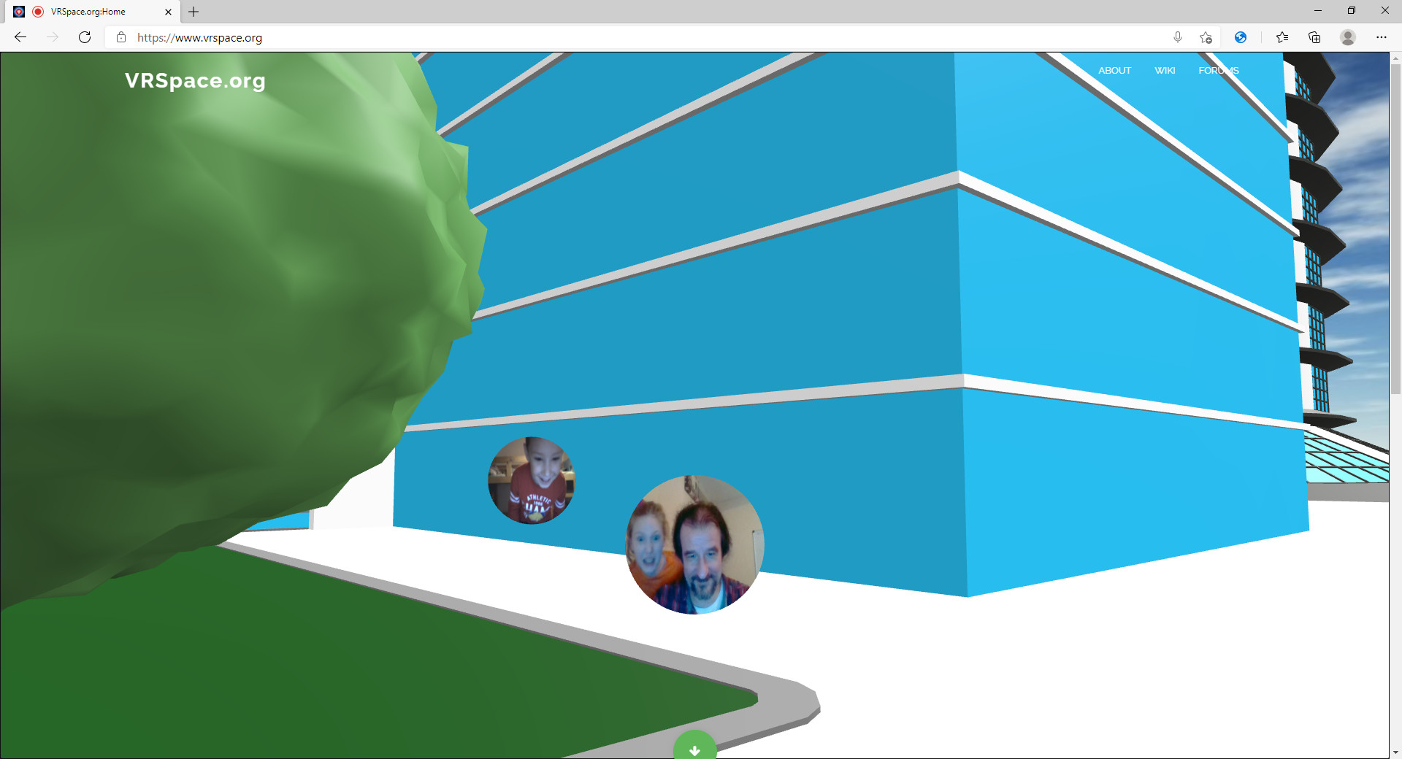Video avatars in 3D world
Credits: fenixman12
Screen sharing is available in only one world – classroom. Click on Share Screen button to share, then choose the window want to share, and it pops up in the classroom for everyone to see. Click the same button to stop sharing.
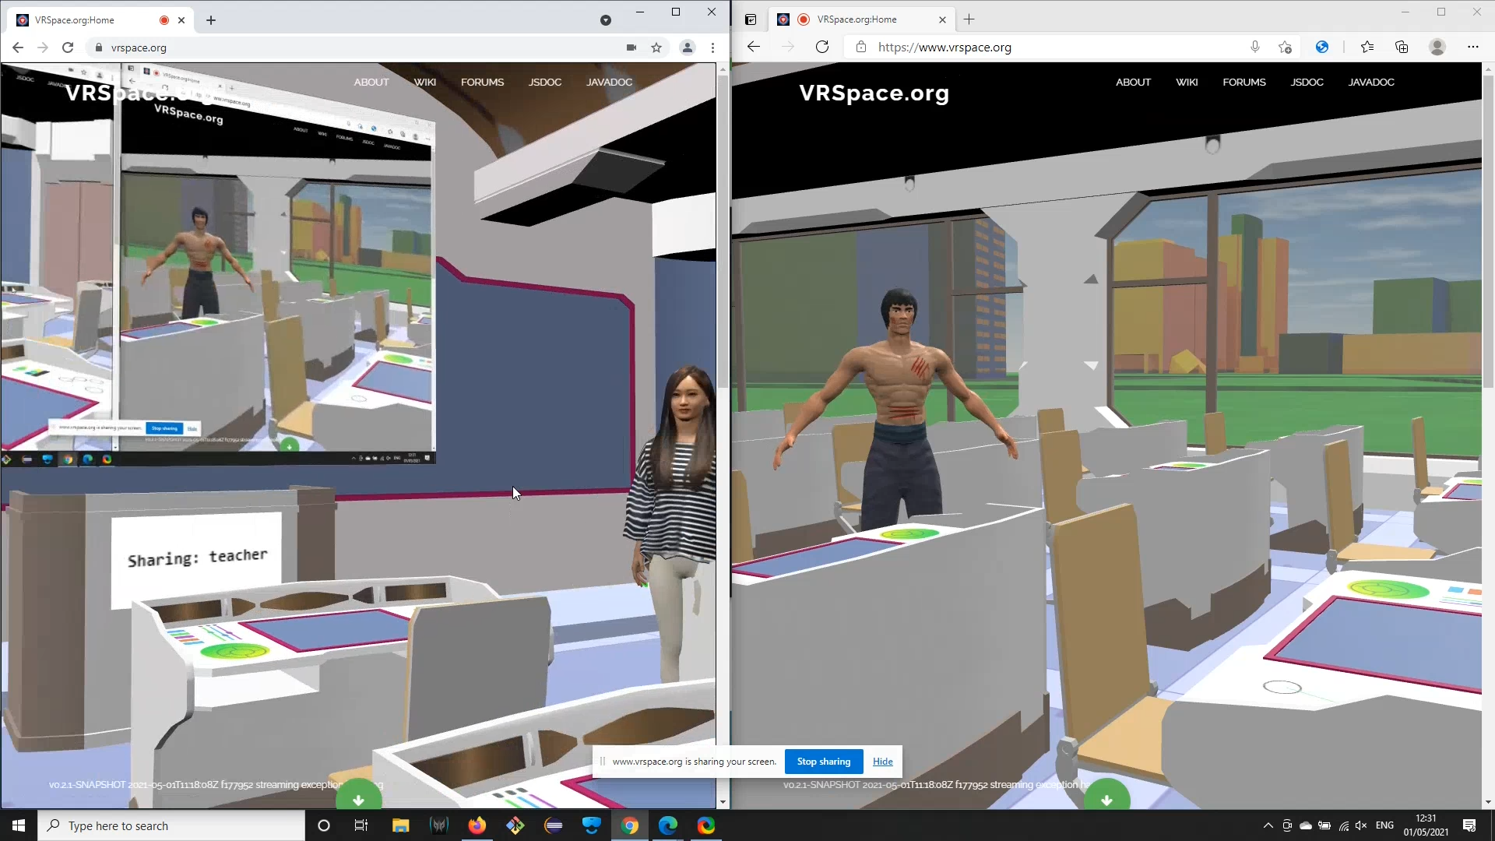A teacher shares her screen in the classroom
Credits: hong227, deto brixen, multimediasheep
But mind that it's a VR server software, not a VR community, at least not yet. VR server is a tool for software and service developers, not for end users.
It provides means to distribute events, share objects, persist state, and other hard stuff, in safe and secure manner. And this demo site is for developers really, as it allows them to connect and create their own spaces, so they don't need to run their own server instances.
It's getting traction in developer community, and handful of early adopters are already making cool 3D multi-user streaming-enabled web sites already.
So, stay tuned! Follow us on github, facebook and youtube.
In the meantime, I'd really love to hear from you: what would you use it for?

